Report: Westside Community Conversation
September 24, 2020 5:30 – 7:45 pm

Main speakers:
Dane County Judge Everett Mitchell
Dane County District Attorney Ismael Ozanne
Police Chief (acting) Vic Wahl

Moderator: Alder Christian Albouras
Alders: Barbara Harrington-McKinney, Donna Moreland, Zachary Henak, Tag Evers, Paul Skidmore, and Christian Alborous.

I. Presentation by Judge Everett Mitchell, Presiding Judge of the Dane County Juvenile Justice System

1.There are three other juvenile judges: Juan Colas, Nia Tramell, and Julie Genovese.

2. Legislative intent of the Dane County Juvenile Justice System:
The intent of the legislature to promote a juvenile justice system capable of dealing with the problem of juvenile delinquency, a system which will protect the community, impose accountability for violations of law and equip juvenile offenders with competencies to live responsibly and productively. To effectuate this intent, the legislature declares the following to be equally important purposes of this chapter:

(a) To protect citizens from juvenile crime.

(b) To hold each juvenile offender directly accountable for his or her acts.

(c) To provide an individualized assessment of each alleged and adjudicated delinquent
juvenile, in order to prevent further delinquent behavior through the development of competency in the juvenile offender, so that he or she is more capable of living productively and responsibly in the community.

(d) To provide due process through which each juvenile offender and all other interested parties are assured fair hearings, during which constitutional and other legal rights are recognized and enforced.

(e) To divert juveniles from the juvenile justice system through early intervention as warranted, when consistent with the protection of the public.

(f) To respond to a juvenile offender’s needs for care and treatment, consistent with the protection of the public, by allowing the court to utilize the most effective dispositional option.

(g) To ensure that victims and witnesses of acts committed by juveniles that result in proceedings under this chapter are consistent with this chapter and the WI Constitution.
They are afforded the same rights as victims and witnesses of crimes committed by adults, and are treated with dignity, respect, courtesy, and sensitivity throughout those proceedings

3. Factors that cause juveniles to enter justice system.

The following chart shows the racial disparities in referring juveniles to the justice system. There have always been a higher number of Black youth than white youth referred to the system. In recent years that number is increasing. Also, the total number of youth in the system decreased om 2011 – 2016, then began increasing since then.
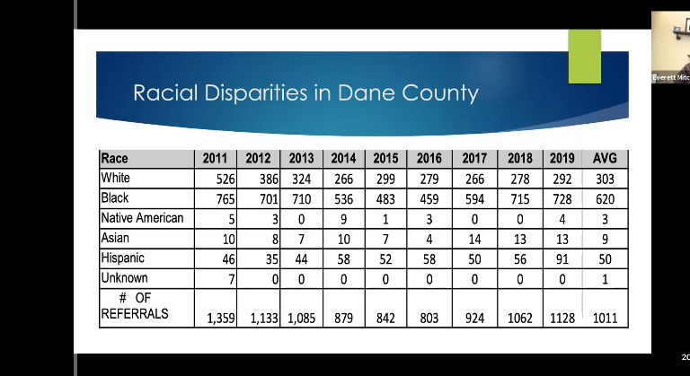
Why this disparity?
You hear about the “School to Prison Pipeline”, but that is not what’s operating in Dane Co.
We have Child Welfare to Juvenile Justice to Adult Prison Pipeline, starting with much younger children. We pass traumatized children from one system to the next.
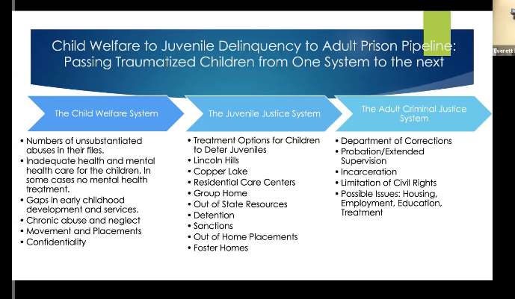

The community often becomes aware of these young people when they hit the juvenile justice system, but many have been in child welfare system for years.

98% of incarcerated youth are trauma survivors. They experience chronic abuse and neglect. Girls are sexually abused, trafficked. What they really need are protective services. Many end up in adult criminal justice system because they weren’t helped as children.

Judge Mitchell said that when he started working in juvenile court in 2015, most workdays ended in tears. He saw how physical, sexual, and emotional abuse led to emotional outbursts that eventually led to criminal behavior. He sentences youth to facilities sparingly because incarceration does not help the youth turn around.

4. “not enough apologies: trauma stories” is a PBS-WI documentary on Juvenile Justice in Dane County.

The documentary follows one youth who, by age 5, had suffered 23 episodes of abuse severe enough to be reported to the authorities. By age 9, he had been in 30 short-term placements. Trauma and abuse in childhood make neurological changes to the developing brain.

When children come to court because a parent has hurt them or not taken care of them, this is a CHIPS ("Child in Need of Protection and/or Services") case. The court may step in to find a safe place for the child to live, maybe with relatives or another family for a while. This temporary family is called a foster care family.
Usually, parents want to have their child live with them. The judge and social workers will work with parents to make their home healthy and safe. If they succeed, then the child can move back home with the parents. This is called reunification.
Sometimes parents can’t make their home safe for the child. Then the judge and others may have to find another home where the child can live safely for a long time. They make a permanent plan for a child.
5. Education and Juvenile Justice
Youth who stay in school have a much better chance of staying outside the system.

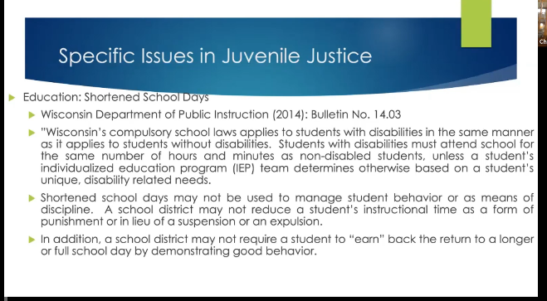

II. Presentation by Dane County District Attorney Ismael Ozanne

1. Role of the District Attorney

The DA's Office covers juvenile and adult systems. Local law enforcement agencies report to the county. They send referrals; the county decides on charges, gets them their day in court, and works to prove charges. County can’t decide on pre-charge or pre-trial incarceration. The County does recommend amount and conditions of bail and inform the courts. Under Marcie’s Law, victims can speak at any hearing that affects them, including bail hearings.

2. Juvenile Justice:

In the case of a juvenile, Human Services gets 45 days to prepare a report and recommend diversion. The DA may accept the recommendations or file charges. Juvenile cases move quickly. Youth go to detention for one day, then they have a hearing. Custody determination is made within 24 hours.

3. Prevention of juvenile crime:

Ozanne: “If we can’t protect children, why wouldn’t we think they’d go in the justice system? Now we have to incarcerate them to make us safer. That doesn’t work long term, it only delays the next incident. We need to think about diversion long before they get to my office. We need to support children and their families so they go to school and succeed.
The biggest deterrent to criminal activity is education. The most important thing we can do is to work with families on positive parenting. Physical discipline may actually be abuse, leading to health and mental health problems.”

Ozanne also said one of the biggest problems is too many guns. This is not about Second Amendment rights. It’s about preventing teenagers from getting easy access to the guns in their homes and on the street.

Some community members are frustrated that juveniles commit crimes, but police don’t pursue them. This is because MPD policy is not to chase in communities—too many instances of innocent people injured because of high speed chases.

This is a particularly difficult time. We have general unrest: peaceful protests, suicides, the pandemic…

III. Presentation by Vic Wahl, Interim Chief of Police, MPD

1. Gun violence is our biggest problem.

The level of gun violence this year is unprecedented. 200 shots fired (90% increase over 2019); 40 people shot; 2 killed; 800 shell casings found by policy. Not just a problem here; it’s happening all across the country.

Gun violence is a public health issue. Many cities (eg, Chicago, Omaha) have addressed gun violence from a data-driven, public health approach. Mayor Soglin put public health positions in his last budget to focus on anti-violence. Working with MPD, the city started to develop a plan. Unfortunately, resources had to be shifted to deal with COVID.

MPD has a long history of building relationships in neighborhoods and schools. Now COVID has put us at a disadvantage—we can’t go out into these spaces.

We’ve tried various approaches to address violence:
-Focused Interruption: people with community credibility go out to defuse situation, tamp down emotions;
-Support to victims to minimize impact on family, eg, providing transportation if their car is taken for evidence.
-Community Restorative Courts:

What can the community do?
Participate in the City budget process: weigh in on funding for MPD, other agencies.

IV. Community Testimony/Q&A

Several people had registered to present their comments formally. Many others participated in the online chat room. The chat room comments were not recorded, but in general, they were in two areas of concern: (1) the police and court system are too lenient with juvenile offenders (2) the police do a good job, and we should not consider defunding policy.

1. Anthony Cooper of the Focused Interruption Coalition
FIC responds to all gun violence incidents, working with perpetrators and victims to help them find a way out of the violence. FIC works to support victims and their families but to prevent retaliatory violence,
The City contracts with FIT and the Nehemiah Center to provide peer support services to people involved in violence and those in need of de-escalation support.
2. Ald Tag Evers
People usually think the term “defund” means eliminating policy departments. In fact, most of the time it’s another way to say “re-think funding.”
Re-thinking means to clarify what we want/need police to do and what are activities we have handed to the police because we failed to handle them well. For example, police were asked to take over mental health crises because when we closed institutions, we didn’t build community support systems for those people.
We don’t really need the police to be the front line with all problems. Groups like the Focused Interruption can defuse crises so police aren’t needed. More important, we need to listen to Judge Mitchell and others: help these kids before they become traumatized.
3. Ald. Zachary Henak
He thinks the police do good work, and it’s important to support them, not defund. When we talk about supporting community services, we should realize the police are one of those services.
Henak pointed to something Ozanne said earlier in the meeting: Dane County is very resource rich. Finding the right ways to distribute those resources is vital, according to Henak.
4. Ald Barbara Harrington-McKinney
We have asked police to be the answer to every problem in society. They encounter people at the worst moment in their life. Community should decide when it’s necessary to call in police.
5. Community Q&A
Q: What can the City Council do about proliferation of guns?
A (Vic Wahl): Unfortunately, nothing. The State Legislature forbade municipalities to restrict gun rights. Some places have done gun buybacks, but research shows they’re ineffective. People will bring in old guns and use the reward money to buy new ones.

Q: Community members believe juveniles are not held responsible for their crimes. They are charged and released with no punishment. Juvenile Justice is a revolving door.
A (Judge Mitchell): This is not true. We have incarcerated more people in Lincoln Hills last year than in the total of the last 10 years. When you hear a juvenile is released, it’s often because the law says they cannot be held in custody prior to being charged.

We have to deal with a fairly small group of kids. Most gangs have only about 30 members. But we incarcerated the majority of the members of one gang, then more came in from outside.

Q: If we have no control over the juveniles, their families should be held responsible.
A (Judge Mitchell): People fail to realize that these youth are not in typical families. Many young people have no families. Their parents abandoned them or were removed because of abuse. Foster families can’t turn the youth around, especially with no supportive services. We don’t even have a job training/education program for these kids to help them become productive and stay off the streets.

A (Ozanne): People should also realize the system has stalled due to COVID. We can’t do social distancing in facilities, so we are reluctant to place juveniles in those.

